### **Pom Pom Chrysanthemum Season**

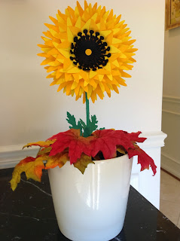

Wouldn't it be nice to have some pom pom chrysanthemums? Yes...they are in season but how would I make one out of paper? I took down the display of paper sunflowers in the classroom and one of the teachers gave me the idea of making pom pom chrysanthemums. I took my torus shape and point edited the edges to create the longer flower petals needed for chrysanthemums. This is not an easy torus to put together...it requires patience. I recommend doing the easier flower torus from a previous post before working up to this one.

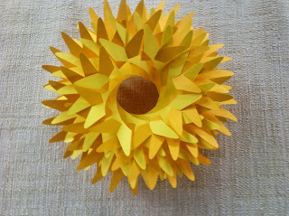

The torus without any embellishments.

I used plastic drinking straws for the stem. I put two straws together by sliding one straw into the other. I wrapped it with green cardstock. I used the shear feature in Silhouette Studio for the first time. This parallelogram piece of paper has a 30 degree horizontal shear so that it wraps nicely around the straw. Train the paper to roll around the straw before gluing...it makes it easier to handle.

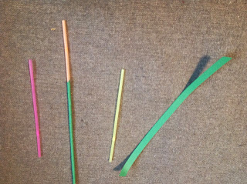

Glue the green cardstock to the straw and also attach the leaves with glue.

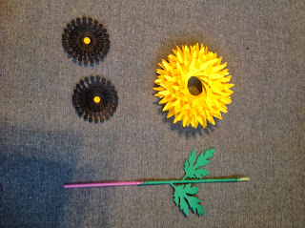

Make the center of the flowers by gluing the stack of embellished circles in ascending order. Add a contrasting circle to the center. Make two...one for each side of the flower.

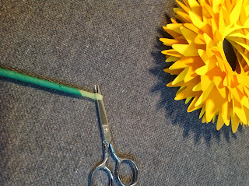

Make a slit in the straw as shown.

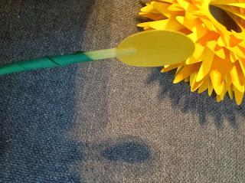

The large circle will be attached to the slit in the straw but don't glue it until you insert the straw into the center of the flower as shown below.

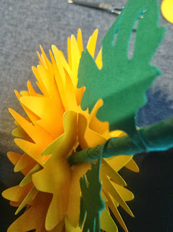

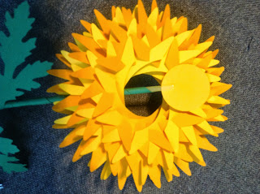

Straw is going through the middle of the flower.

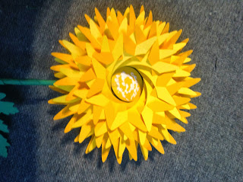

Glue the circle and attach one of the centers. Repeat this step for the other side. Please be patient. Let the glue dry for awhile before moving the flower to ensure that both sides of the middle of the flower remain attached to one another.

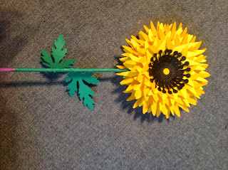

Finished flower before the bottom of the stem was cut off.

|  |
| --- |
|  |
| I put one of the Pom Pom Chrysanthemums in a flower pot with some oasis as support. I am going to keep one of the flowers at home and I will bring the other one to school. |

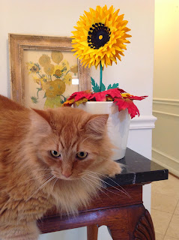

Marley always want to get into the picture.

I painted Vincent Van Gogh's Vase with Fifteen Sunflowers last year. I think my torus mimics one of the flowers in the painting.

Update...I added a wooden skewer to the center of the straw. The flower was starting to bend because of the weight of the flower.